PROJECT TITLE: FARMERS MANAGEMENT SYSTEM APPLICATION
STUDENT NAME: FAITH MUTUKU
ADMISSION NUMBER: BIT/2024/55704

INTRODUTION
This is a system developed to help farmers access their buyers directly with no middle men involved.
The system allows the farmers to showcase their products directly.
The application aims at reducing dependency and improving profit margins

INSTALLATION OF SOFTWARE
WEEK 1

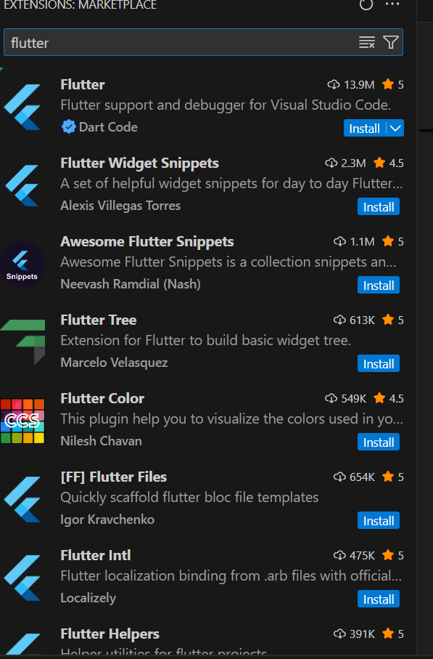
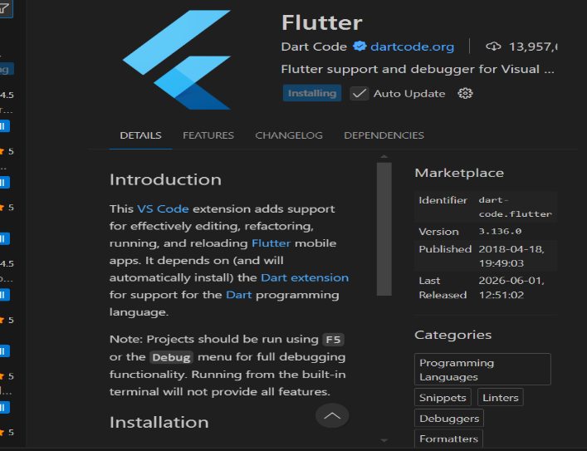
WEEEK 2&3
LOGIN SCREEN
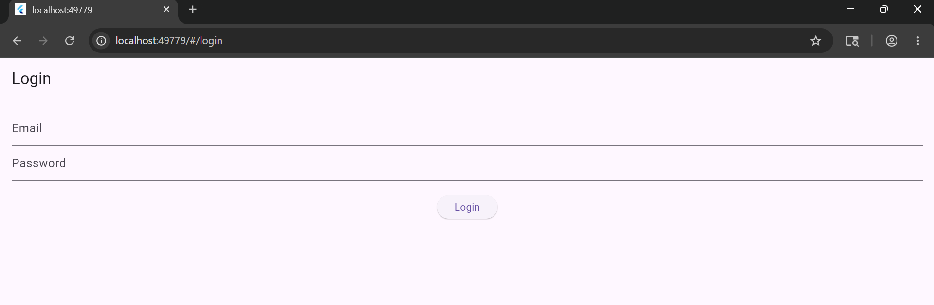

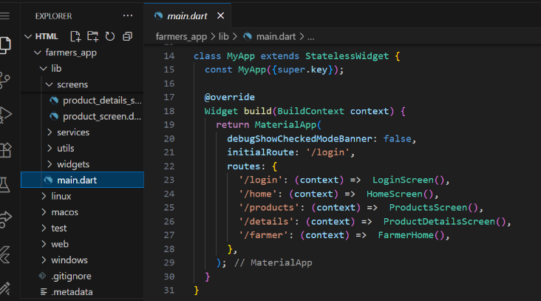

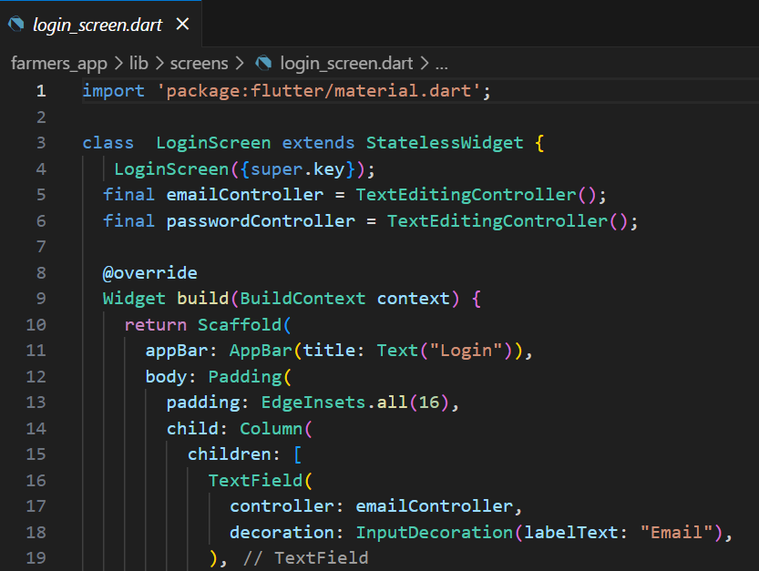

HOMEPAGE

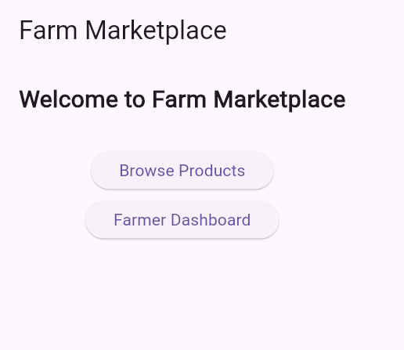
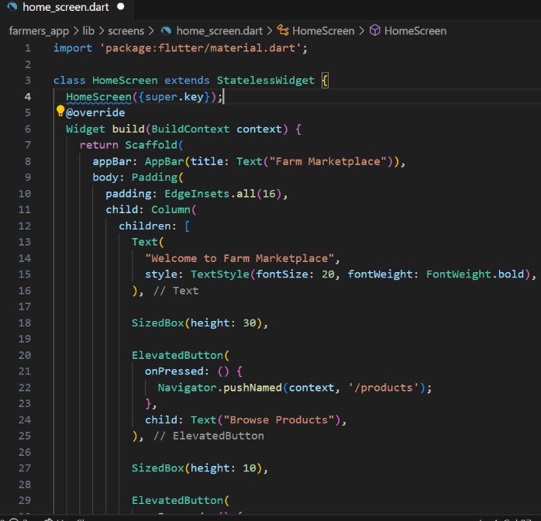

PRODUCT SCREEN

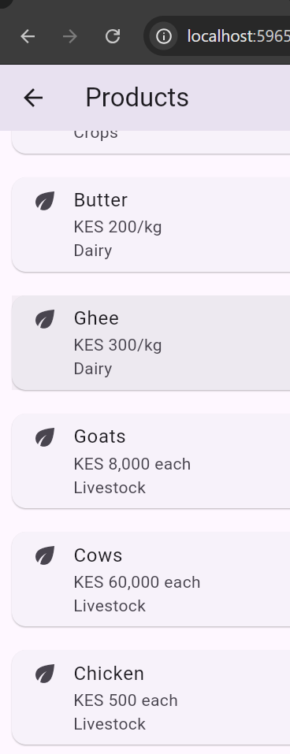
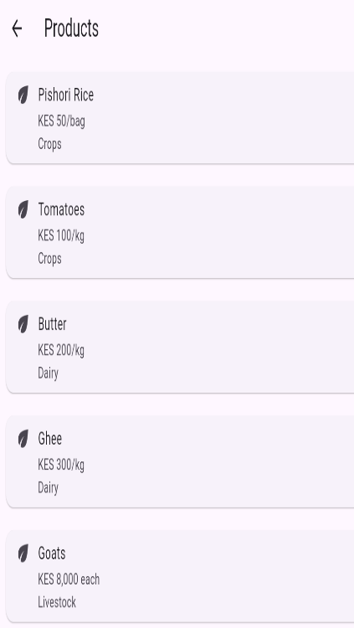

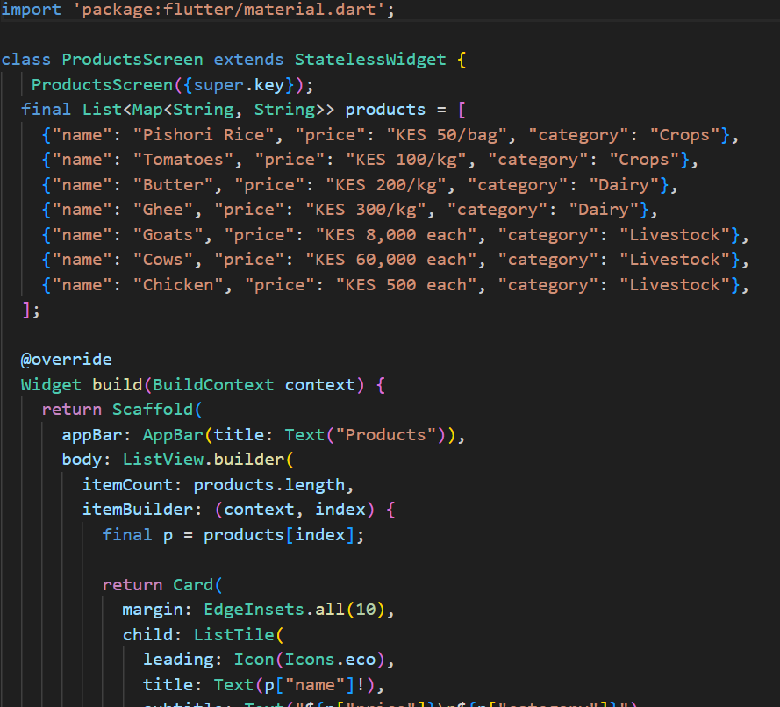

PRODUCT DETAILS EXAMPLE OF ONE

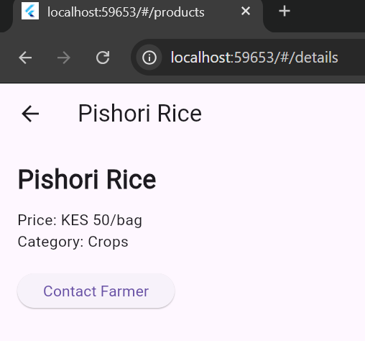

FARMERS DASHBOARD TO ADD PRODUCTS

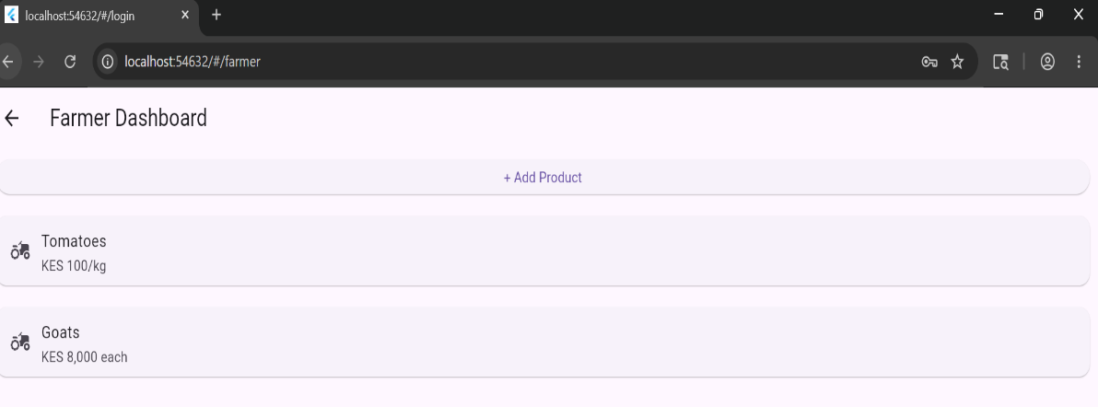
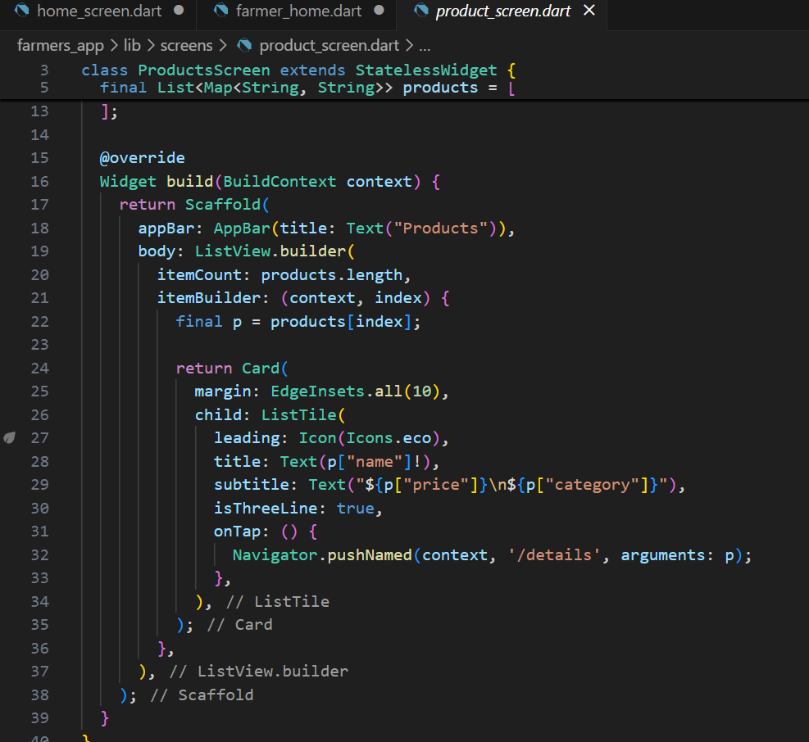
CHALLENGES SO FAR

Faced challenges in firebase authentication the system was crushing still searching for a way to navigate

